MULTIPLE CHOICE QUESTIONS
MATHS
GRADE: I_____
NAME: _________________________ MARKS: 25
- The number of smilies in the picture is____________.
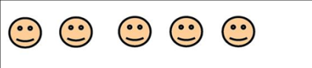
- 4 b) 5 c) 6
- The number of flowers is____________.
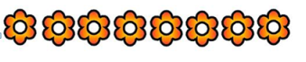
a) 8 b) 5 c) 6
- The number of hearts is____________.
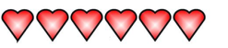
a) 4 b) 5 c) 6
- What is 5-3?
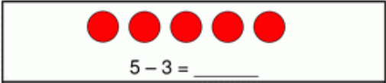
a) 4 b) 5 c) 2
- What is 9-5?
- 4 b) 5 c) 6
- The sum of 3 and 5 is
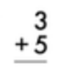
a) 9 b) 8 c) 6
- The sum of 3 and 2 is
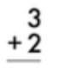
- 5 b) 8 c) 6

- The sum of
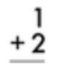
- 5 b) 3 c) 6

- Insert the correct symbol inside the box
a) < b) > c) =
- Insert the correct symbol inside the box
a) < b) > c) =
- Insert the correct symbol inside the box
a) < b) > c) =
12. What is one less than the given number?
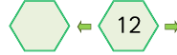
- 11 b) 8 c) 6

13. What is one less than the given number?
- 11 b) 8 c) 10

14. . What is one more than the given number?
- 13 b) 15 c) 6

15. Number the objects from smallest to the biggest.
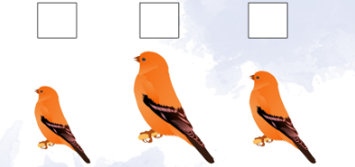
The series of numbers is
- 2,3,1 b) 1,2,3 c) 3,1,2

16. Number the objects from shortest to the longest.
- 2,3,1,4 b) 4,1,2,3 c) 4,1,3,2
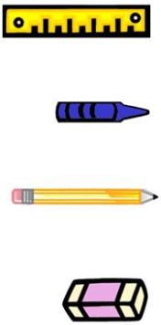
17. The number of sides of a triangle is ______________
- 2 b) 3 c) 4
18. Identify the shape.
- circle b) round c) oval
18. What is the shape of the object?
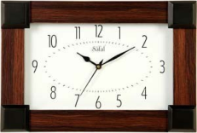
- rectangle b) round c) square
19. The shape of mobile phone is ______________________
- rectangle b) round c) square
20. In which shape all the four sides are equal?
- rectangle b) round c) square

21. How many corners are there for a circle?
a) 1 b) 0 c) 4
22. What comes in between 9 and 11?
a) 10 b) 8 c) 12
23. What comes before 8?
a) 9 b) 10 c) 7
24. What is 5+0=?
a) 6 b) 0 c) 5
25. Rani has 7 cakes. She gave 1 to Ram. How many cakes does she have now?
a) 7 b) 8 c) 6

